GOVT POLYTECHNIC COLLEGE BHIKHIWIND(TARN TARAN)
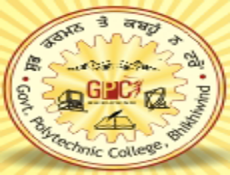

AN INDUSTRIAL TRAINING PROJECT REPORT ON

SHOP IN

‘C++’ LANGUAGE

COMPUTER ENGINEERING

IN

5th SEMESTER

SUBMITTED TO: SUBMITTED BY:
ER. Padamjit SIMARJIT SINGH
Reg.No.8391

INDEX

Sr. no. | NAME | PAGE NO.
1. | Acknowledgement | 1
2. | Abstract of project | 2
3. | Introduction of c++ | 3-10
4. | About of project | 11
5. | Working description of project | 12
6. | Header files and their purpose | 13
7. | Files generated | 14
8. | Outputs | 15-19
9. | Conclusion | 20
10. | Scope of future | 21
11. | Bibliography | 22

